**Proposal and Architecture Design for Intelligent Factory Monitoring System**

1. **Objectives**
2. **Predictive Monitoring:**

The primary goal of predictive monitoring is to anticipate potential issues before they occur, allowing for proactive rather than reactive management of factory operations. This objective involves:

1. Real-time Data Analysis:

* Continuously process and analyze data streams from all connected sensors and systems.
* Utilize machine learning and time series forecasting algorithms to detect patterns and anomalies that may indicate any upcoming issues.

1. Real-time event prediction

* Develop models to predict future events such as machine downtimes and safety incidents based on current operational parameters.
* Utilize the 10+ years of historical data, including sensor readings, machine performance metrics, and environmental data, to train these predictive models.
* Aim for high accuracy: at least 85% for machine downtimes and 90% for safety incidents.

1. Multi-source Data Integration:

* Integrate data from various sources including:
* Operational Data: Sensor readings (temperature, pressure, vibration), machine performance metrics, and environmental data.
* Event Data: Historical records of downtimes, anomaly detection logs, and preventative maintenance records.
* Maintenance and Fixes Data: Maintenance logs, SOPs, and employee observations.
* Ensure real-time processing of incoming data to enable timely predictions.

1. Machine Learning Models:

* Develop and deploy multiple machine learning models, each specialized for different types of predictions (e.g., separate models for predicting machine downtimes, quality issues, and safety incidents).
* These models will be trained on the extensive historical data, learning to recognize the subtle precursors of various events.

1. Performance Metrics:

* We can use different performance metrics like R-Squared & Adjusted R-Squared, to make the ML model efficient by optimizing the over or under-fitting of the model.
* We can try to achieve model accuracy above 85% to avoid under fitting of the model and make sure it doesn’t go beyond 97% which will lead to overfitting of the model.
* Since we have different aspects like safety of workers, machine downtime etc. to consider, so accuracy must not be the only performance metric to consider we should also consider precision and recall.
* For most scenarios we can use f1 score, but for safety incidents we can target for more recall value due to the critical nature of these events.

1. Early Warning System:

* Implement a tiered warning system that categorizes predictions based on urgency and potential impact.
* Provide notifications with sufficient lead time for intervention, considering the nature of different events (e.g., imminent machine failure vs. long-term degradation).

1. Continuous Learning:

* Incorporate feedback loops to continuously refine and improve the predictive models based on new data and outcomes.

1. **Root cause Analysis**

The objective is to not only predict events but also to understand why they are occurring or likely to occur.

* 1. Automated Analysis System:
* Develop an AI-driven system that automatically initiates a root cause analysis when an event is predicted.
* This system will analyze historical data, current operational parameters, and known causal relationships to identify potential root causes.
  1. Multi-level Analysis:
* Implement a hierarchical approach to root cause analysis, identifying both immediate technical causes and broader systemic or procedural issues.
* For example, a predicted machine failure might be immediately caused by a worn part, but the root cause could be an inadequate maintenance schedule or a systemic issue with the supply chain for replacement parts.
  1. Integration of Domain Knowledge:
* Incorporate information from maintenance logs, SOPs, troubleshooting guides, and employee notes to enhance the root cause analysis.
* Develop methods to translate unstructured data (like employee observations) into structured inputs for the analysis system.
  1. Historical Pattern Recognition:
* Implement algorithms to recognize patterns in historical event data that may indicate common root causes or contributing factors.
* Use this pattern recognition to improve the accuracy and speed of root cause identification for new events.
  1. Recommendation Engine:
* Develop a system that not only identifies root causes but also suggests potential solutions or preventive measures based on historical data and best practices.

1. **Automated Notifications**

This objective focuses on ensuring that the right information reaches the right people at the right time, facilitating rapid and effective responses. It includes:

Intelligent Summarization:

* Utilize the language model to generate clear, concise, and contextually relevant summaries of predicted events and their root causes.
* Ensure that these summaries include key details such as the nature of the event, likelihood, potential impact, and suggested actions.

Targeted Distribution:

* Develop a sophisticated routing system that determines the appropriate recipients for each notification based on the nature of the predicted event, its severity, and the identified root causes.
* Ensure that notifications are sent to the relevant department or personnel who can take immediate action.

Multi-channel Communication:

* Implement email as the primary notification method, as specified in the scenario.
* Consider additional channels (e.g., SMS, in-system alerts) for urgent issues, ensuring comprehensive coverage.

Timely Delivery:

* Set and meet a target of sending notifications within 5 minutes of event prediction and root cause analysis completion.
* Implement a priority system to ensure critical notifications are sent and received without delay.

Feedback Mechanism:

Implement a system for recipients to provide feedback on the accuracy and usefulness of notifications.

* Use this feedback to continually improve the prediction, analysis, and notification systems.

1. **Architecture Diagram**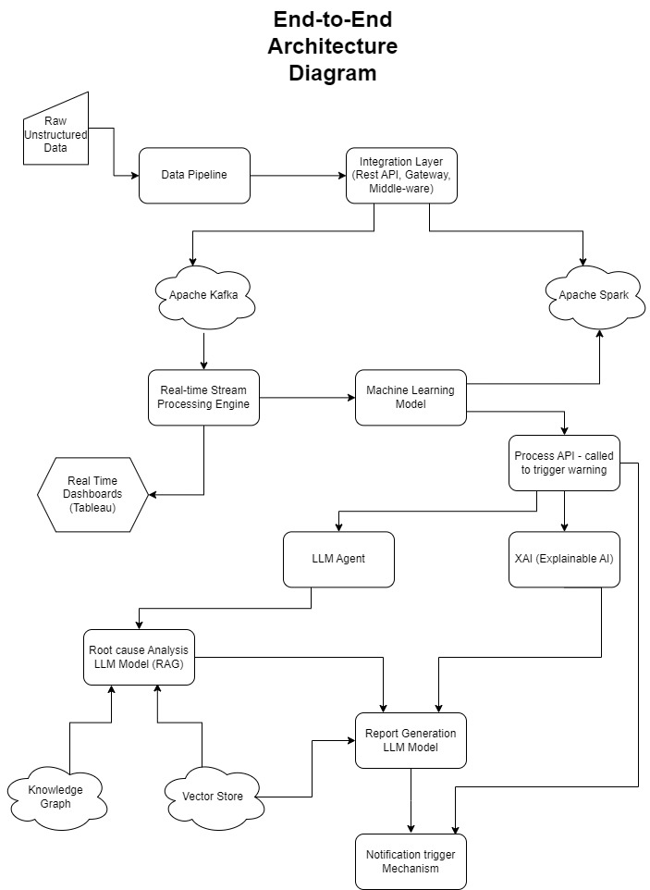
2. **Technical Specification**
3. **Model Training**

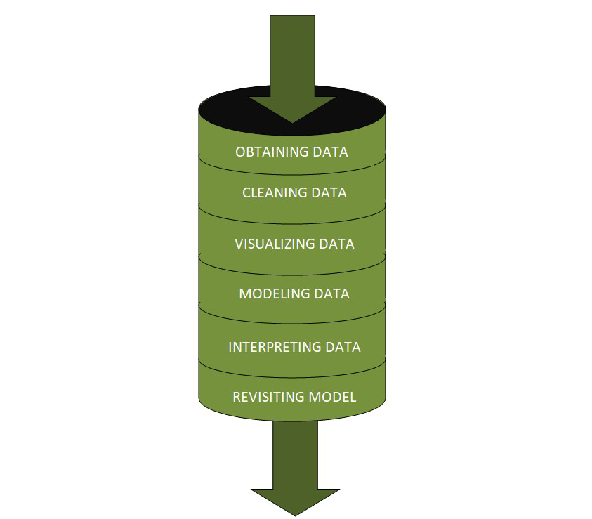

1. Fetching/Obtaining the Data

* This stage involves the identification of data from the databases and extracts into useful formats.
* Also, it involves sampling the data for training the model.

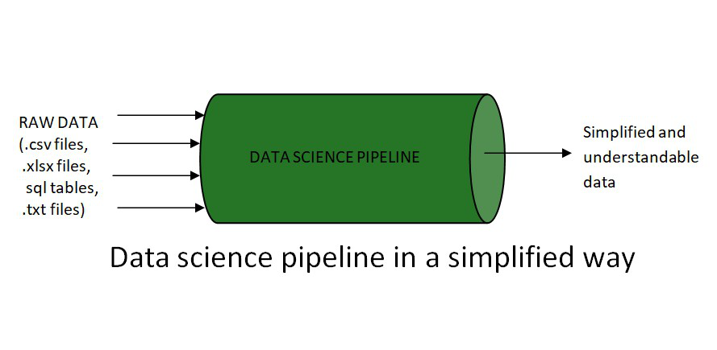

1. Data Cleaning/ Scrubbing and Pre-processing

* Handle missing values using techniques like removing/ dropping missing values, imputing missing values (Mean/Median/Mode Imputation, Imputation Using algorithms like k-Nearest Neighbours (KNN), Linear Regression etc., impute with constant values).
* Normalize numerical features using techniques like log transformation, maximum absolute scaling or min max scaling.
* Standardize numerical features using packages like StandardScaler from sklearn or technique like z-score standardisation
* Encode categorical variables using techniques like one-hot encoding or target encoding.
* Handle date and time values by having proper format and extract the necessary data from it.
* Handle imbalanced data by using packages like SMOTE, Random Over and Under Sampler.

1. Exploratory Data Analysis

* Data Profiling:
* Generate comprehensive statistical summaries for all variables (mean, median, mode, standard deviation, quartiles, etc.).
* Identify data types, ranges, and distributions of each feature.
* Detect outliers and anomalies using methods such as Z-score and Interquartile Range (IQR).
* Correlation Analysis:
* Compute correlation matrices to identify relationships between variables.
* Utilize heat maps for visual representation of correlations.
* Perform principal component analysis (PCA) to understand feature importance and dimensionality.
* Visualization:
* Create histograms and box plots to understand data distributions and identify outliers.
* Use scatter plots and pair plots to visualize relationships between variables.
* Implement time series plots with moving averages to visualize trends over time.
* Utilize advanced visualization libraries like Matplotlib, Seaborn and Plotly for interactive, dynamic visualizations.

1. Feature Selection:

* Numerical & Categorical Features:
* Use techniques like ANOVA, t-test or chi-square test to select categorical features
* Use technique like correlation matrix or feature_selection classes from sklearn
* Algorithms like Random Forest or Recursive feature elimination also can be used.
* Text-based Features
* Apply Count Vectorizer or TF-IDF (Term Frequency-Inverse Document Frequency) Vectorizer to extract important terms.
* Use word embeddings (e.g., Word2Vec) to create numerical representations (vectors) of textual notes.
* Anomaly Scores
* Implement unsupervised anomaly detection algorithms (e.g., Isolation Forest, One-Class SVM) on raw data.
* Use the anomaly scores as features in the predictive models.
* Dimensionality Reduction
* Apply Principal Component Analysis (PCA) or t-SNE to create lower-dimensional representations of high-dimensional sensor data.
* Select features based on the variance and outcome.

1. Model Selection and Training

* Time Series Forecasting:
* ARIMA (AutoRegressive Integrated Moving Average) for univariate time series prediction.
* Prophet by Facebook for multi-variable time series with strong seasonal patterns.
* Machine Learning Models:
* Density Based Scan (DBScan): For anomaly/outlier detection and clustering
* Linear Regression: For handling linearly relational data and features.
* Random Forest: For handling non-linear relationships and feature importance analysis.
* Gradient Boosting Machines (e.g., XGBoost, LightGBM, ADABoost), for high performance and handling of imbalanced datasets.
* Long Short-Term Memory (LSTM) networks: For capturing long-term dependencies in sequential data.

1. Training Process

* Split the data as train and test split with a fixed random state
* Use k-fold cross-validation and grid search cross-validation for model evaluation and hyperparameter tuning.
* Use more training data in case of model under fitting
* Use below mentioned optimization techniques in case of model overfitting –
* Early stopping
* Dropout
* L1/L2 reguralisation
* K-Fold Cross validation
* Pruning
* Use Ensemble techniques like averaging, weighted averaging, voting classifier for better accuracy and multi-model prediction

1. Model Versioning and Management

* Use MLflow for experiment tracking, model versioning, and deployment management.
* Implement A/B testing framework for comparing model performance in production.

1. Data Storage

* Use Apache Spark, for storing, retrieving, archiving and processing training, historical and other data.
* Use FAISS(Facebook AI Similarity Search), for storing and retrieving large-scale vectors.
* Use Neo4j for storing and retrieving knowledge graphs.
* Use Kafka, for real time data streaming and retrieval.

1. Explainable AI Integration

* LIME (Local Interpretable Model-agnostic Explanations)
* Implement LIME for generating human-readable explanations of model predictions:
* Create surrogate linear models to approximate local decision boundaries.
* Generate textual explanations highlighting the most important features for each prediction.
* Use the lime Python library and customize it for the specific domain and data types.

1. **Root Cause Analysis**
   1. Data Integration

* Text Mining and Natural Language Processing
* Implement advanced NLP techniques to extract structured information from unstructured maintenance notes and logs:
* Named Entity Recognition (NER) to identify equipment names, parts, and technical terms.
* Dependency parsing to understand relationships between entities in text.
* Use spaCy and NLTK for NLP tasks and train custom models on domain-specific technical language.
* Knowledge Graph Creation

Use Neo4j and create a knowledge graph integrating:

* Historical event data
* Maintenance logs
* Repair records
* Equipment specifications
* Operational parameters

Add a vector index using llamindex to a knowledge graph to represent unstructured text data and find relevant texts using vector similarity search

* Vector Database creation
* Use Sentence transformers to create dense vector embeddings (e.g., MPNET, MiniLM) to encode reports into documents.
* Implement an efficient similarity search using FAISS or Annoy for fast retrieval.

* 1. Causal Inference Techniques with RAG and Prompt Engineering
* RAG-enhanced Causal Discovery  
  + For a given event or failure, generate a query embedding.
  + Retrieve relevant documents and causal graphs from the knowledge base.
  + Construct a prompt that includes the retrieved information and the current system state.
  + Use the language model to generate potential causal relationships and explanations.
  + Validate generated hypotheses against available data and domain constraints.
* Prompt Engineering based Report generation
* Use combination of different techniques like Chain-of-thought (CoT), Generated knowledge prompting and Few shot prompting to generate the reports.
* Explainable Causal Inference
* Generate natural language explanations of causal relationships and inferences.
* Produce step-by-step reasoning chains for complex causal conclusions.
* By using RAG the previous reports can be retrieve from FAISS and achieve the same inference
  1. Implementation
* Use the LangChain framework for implementing the RAG pipeline and managing interactions with the language model.
* Employ Hugging Face's Transformers library for accessing language models.
* Implement a custom prompt template system using Jinja2 for flexible and dynamic prompt construction.
* Develop a WebSocket-based API for real-time interaction with the causal inference system, allowing for iterative refinement of analyses.

1. **Language Model Integration**

1. Model Selection

* Base LLM Model: Claude-6.5 sonnet or GPT-7, depending on availability and performance requirements.
* Sentence Transformer: MPNET or MiniLm

1. Model Evaluation criteria:

* Performance on relevant NLP tasks (e.g., summarization, question-answering)
* Inference speed and resource requirements
* Cost considerations for API usage or self-hosting
* Prompt Engineering and Management

1. Prompt Template System

* Develop a flexible prompt template system:
* Use Jinja2 for dynamic prompt construction
* Create a library of prompt templates for different tasks and scenarios

1. Prompt Generation

* Few Shot Prompting - provides models with a few input-output examples to induce an understanding of a given task, unlike zero-shot prompting, where no examples are supplied.

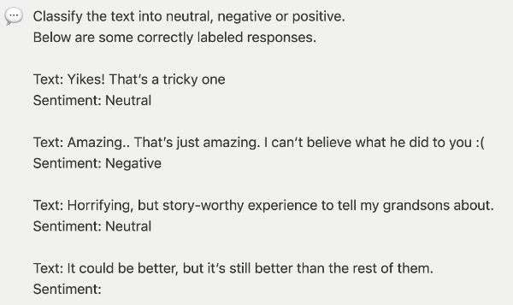

* Retrieval Augmented Generation (RAG) - Integrates information retrieval into text generation, overcoming the limitations of static training data in LLMs. By analyzing user input and querying a knowledge base, RAG enriches prompts with contextual background, enabling accurate and creative responses. It outperforms traditional models on ODQA benchmarks like TriviaQA and Natural Questions, achieving exact match scores of up to 56.8% and 77.5%, respectively, marking a significant advancement in text generation tasks requiring external knowledge.

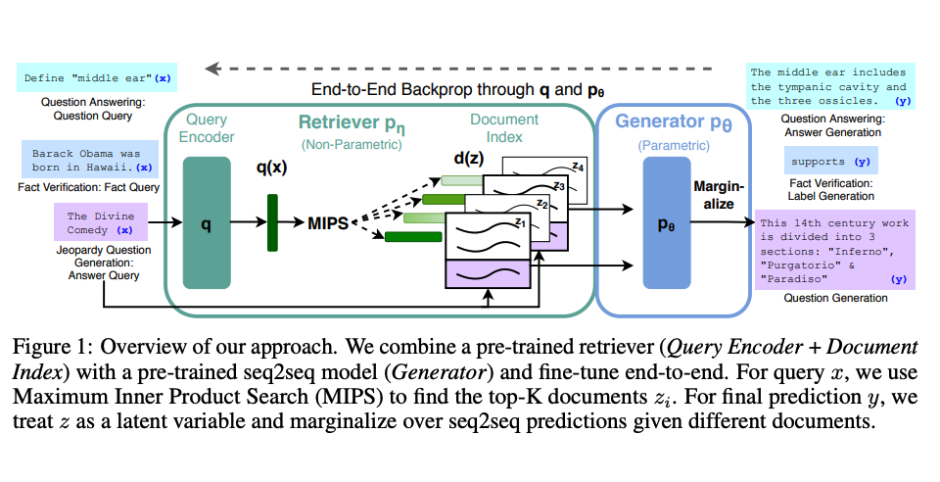

* Chain-of-Thought (CoT) Prompting - introduces a method to prompt LLMs, fostering coherent and step-by-step reasoning. This technique stands out for its capacity to elicit more structured and thoughtful responses compared to conventional prompts. Through experiments, CoT prompting demonstrates its ability to guide LLMs through logical reasoning chains, resulting in deeper comprehension of prompts and more accurate responses, akin to human problem-solving processes.

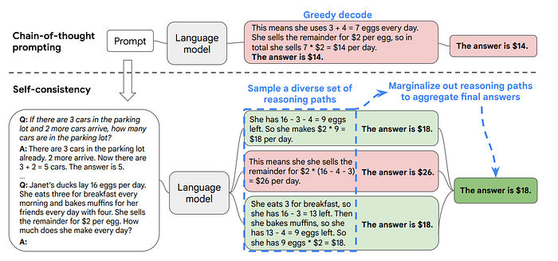

* Generated knowledge prompting - method that first prompts the LLM to generate useful knowledge related to the task, and then incorporate the knowledge into the prompt alongside the question or task description. ‍

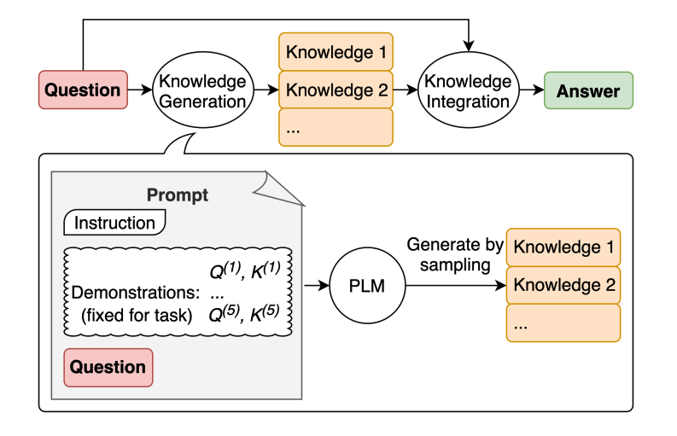

* + Context Window Management
* Implement intelligent context window management:
* Develop algorithms to select the most relevant information for inclusion in the prompt
* Use ranking techniques for processing long documents
* Output Processing
* Implement a post-processing pipeline to ensure generated summaries adhere to predefined structure and length constraints.
* Use a fact-checking module that cross-references generated content with the input data to ensure accuracy.

1. Integration with Prediction and Root Cause Analysis Systems

* API Development
* Design and implement a RESTful API for the language model service:
* Endpoints for generating event summaries, root cause analyses, and explanations
* Support for batch processing and streaming responses
* Develop SDKs in Python and JavaScript for easy integration with other system components
* Input Formatting and Output Parsing
* Develop a robust input formatting system:
* Create endpoints for different types of requests (e.g., event summary, root cause analysis)
* Implement a schema validation layer to ensure input quality or a pydantic model
* Design an output parsing module:
* Extract structured information from generated text (e.g., event severity, recommended actions)
* Implement error handling and fallback mechanisms for unexpected outputs
* Asynchronous Processing
* Implement an asynchronous processing system:
* Use Apache Kafka for reliable message delivery
* Implement a notification system for completed tasks:
* WebSocket-based real-time notifications
* Email notifications for critical analyses

1. Continuous Improvement and Feedback Loop  
   * User Feedback System

* Develop an intuitive feedback interface:
* Allow users to rate the quality and relevance of generated content
* Implement a system for users to suggest corrections or improvements
* Create a feedback analytics dashboard using Tableau or Qlik:
* Track feedback metrics over time
* Identify patterns in user satisfaction and model performance  
  + Retraining and Model Updates
* Establish a regular retraining schedule:
* Incrementally update the model with new data and feedback
* Implement automation test suites for testing updated models
* Develop a model rollback system:
* Ability to quickly revert to previous model versions if issues are detected
* Maintain a model version history with performance metrics

1. **System Integration and Deployment**
2. Component Integration  
   * Data Pipeline Integration

* Integrate data ingestion systems with factory sensors and existing databases:
* Develop custom connectors for each data source (operational data, event data, maintenance logs)
* Implement real-time data streaming using Apache Kafka for sensor data
* Set up batch processing jobs for historical data ingestion
* Establish data preprocessing pipeline:
* Implement feature engineering processes as defined in the Model Training section
* Ensure data quality checks and normalization procedures are in place
  + Model Integration
* Integrate predictive models with the real-time data stream:
* Deploy time series forecasting models (ARIMA, Prophet) and machine learning models (Random Forests, Gradient Boosting Machines) as microservices
* Implement model versioning and A/B testing capabilities
* Connect root cause analysis models to the prediction pipeline:
* Deploy causal inference models
* Establish feedback loops for continuous model improvement
* Establish CI/CD pipeline
* Integrate predictive models with vector and knowledge graph databases

1. Deployment Architecture  
   * Microservices Structure

* Design and implement microservices for key system components:
* Data Ingestion Service
* Data Preprocessing Service
* Prediction Service
* Root Cause Analysis Service
* Language Model Service
* Notification Service
* Implement service discovery and load balancing:
* Use Cloud based services (AWS EKS, ECS, EC2), Kubernetes or Openshift for container orchestration and scaling
* Set up an API Gateway for managing external access to services  
  + Data Storage and Management
* Deploy scalable data storage solutions:
* Use a time-series database for high-frequency sensor data
* Implement a document store for maintenance logs and event data
* Set up a distributed file system (Spark) for large-scale data processing  
  + Model Serving Infrastructure
* Deploy model serving platforms:
* Use LlamaIndex, Langchain, TensorFlow Serving for machine learning models
* Implement custom serving solutions for time series and causal inference models  
  Set up GPU-enabled instances for language model inference

1. Deployment Process  
   * Staging Environment

* Set up a staging environment that mirrors the production factory setting:
* Deploy all components on a scaled-down infrastructure
* Use anonymized historical data for testing and validation  
  + Phased Rollout
* Implement a phased deployment strategy:
* Deploy data ingestion and storage systems
* Roll out preprocessing and feature engineering pipelines
* Deploy predictive models and root cause analysis systems
* Integrate language model for summary generation
* Implement notification system and user interfaces  
  + Monitoring and Logging
* Set up comprehensive monitoring for all system components:
* Implement centralized logging using the ELK stack (Elasticsearch, Logstash, Kibana)
* Use AppDynamics, Kibana, Tableau, Qlik for metrics collection and for visualization
* Establish alerting mechanisms for system health and performance issues

1. Security and Compliance  
   * Data Protection

* Implement encryption for data at rest and in transit
* Set up access controls and authentication mechanisms for all system components  
  + Regulatory Compliance
* Ensure system design and deployment adhere to relevant industry standards and regulations
* Implement audit logging for all critical operations and data access

1. Training and Handover  
   * Operator Training

* Develop training programs for factory personnel:
* Create documentation and user guides for each system component
* Conduct hands-on training sessions for system operation and maintenance  
  + Support and Maintenance Plan
* Establish procedures for ongoing system support:
* Set up a helpdesk system for issue reporting and tracking
* Develop a maintenance schedule for regular system updates and optimizations

1. **Documentation and reporting**
2. **Description**: Document the entire training process, model details, and evaluation results for transparency, reusability and reproducibility.
3. **Steps**:
4. **Code Documentation**: Ensure that the code is well-documented.
5. **Model Description**: Provide detailed information about the model architecture, hyperparameters, and training process.
6. **Performance Report**: Summarize the model's performance metrics and evaluation results.
7. **Docstrings**: Ensure that the Python module, class, function or method are documented in the docstrings
8. **Cloud storage**: Ensure that all the documents are uploaded on the shared cloud platform or on Confluence
9. **Delivery Implementation Plan**
10. **Phased Approach**

**Phase 1**: Data Integration and Infrastructure Setup (Months 1-3)

a) Data Assessment and Preparation

* Develop data cleaning and normalization procedures
* Set up data pipelines for continuous data ingestion

b) Infrastructure Setup

* Deploy necessary hardware for on-premises computing (if required)
* Set up cloud infrastructure for data storage and processing
* Implement security measures and access controls

c) Initial Dashboard Development

* Create basic dashboards for data visualization
* Implement real-time monitoring of key factory metrics

Deliverables:

* Integrated data repository
* Functional data pipelines
* Basic monitoring dashboard

**Phase 2**: Predictive Model Development (Months 4-6)

a) Feature Engineering

* Develop relevant features from raw data
* Implement automated feature extraction pipelines

b) Model Development and Training

* Develop initial predictive models for machine downtime
* Train models using historical data
* Implement model validation and testing procedures

c) Integration with Data Pipeline

* Set up real-time data flow to predictive models
* Implement logging for model predictions

Deliverables:

* Functional predictive models for machine downtime
* Real-time prediction pipeline

**Phase 3**: Root Cause Analysis Implementation (Months 7-9)

a) Causal Model Development

* Develop Bayesian Network models for causal inference
* Implement pattern mining algorithms for identifying common failure sequences

b) Integration with Predictive Models

* Connect root cause analysis models to predictive model outputs
* Implement triggering mechanism for automatic root cause analysis

c) Historical Analysis Module

* Develop module for analyzing historical events and their resolutions
* Integrate findings into root cause analysis process

Deliverables:

* Functional root cause analysis system
* Integrated predictive and causal models

**Phase 4**: Language Model Integration and Notification System (Months 10-12)

a) Language Model Fine-tuning

* Fine-tune selected language model on domain-specific data
* Develop prompt engineering techniques for event summarization

b) Notification System Development

* Implement email notification system
* Develop routing logic for directing notifications to appropriate departments

c) Integration and Testing

* Integrate language model with predictive and root cause analysis systems
* Conduct end-to-end testing of the entire system

Deliverables:

* Functional notification system with language model integration
* Fully integrated intelligent monitoring system

**Phase 5**: Pilot Deployment and Optimization (Months 13-15)

a) Pilot Deployment

* Deploy system in a limited section of the factory
* Train relevant personnel on system usage

b) Performance Monitoring and Optimization

* Collect feedback from users
* Fine-tune models and adjust system parameters based on real-world performance

c) Scaling Preparation

* Address any scalability issues identified during the pilot
* Prepare for full-scale deployment

Deliverables:

* Successful pilot deployment
* Optimization report and scaling plan

1. **Deployment**

**Full-Scale Deployment** (Months 16-18)

a) Staged Rollout

* Gradually expand system deployment across all factory sections
* Implement in order of criticality, starting with most critical areas

b) Integration with Existing Systems

* Fully integrate with Manufacturing Execution System (MES)
* Establish data exchange with Enterprise Resource Planning (ERP) system
* Connect with SCADA system for comprehensive monitoring

c) User Training and Support

* Conduct comprehensive training sessions for all relevant personnel
* Set up help desk and support system for user assistance

d) Performance Validation

* Conduct thorough testing in each area post-deployment
* Validate system performance against predefined KPIs

**Deliverables:**

* Fully deployed intelligent monitoring system
* Integration with all relevant factory systems
* Trained personnel and active support system

1. **Maintenance**

Ongoing Maintenance and Update Plan

a) Regular System Audits

* Conduct monthly system health checks
* Perform quarterly comprehensive audits of all system components

b) Continuous Model Updating

* Retrain predictive models monthly with new data
* Update root cause analysis models based on new findings and expert input
* Fine-tune language model quarterly with new domain-specific data

c) Performance Monitoring

* Implement automated performance monitoring for all system components
* Set up alerts for any degradation in prediction accuracy or system performance

d) Periodic System Updates

* Schedule bi-annual system updates for software components
* Plan annual hardware upgrades or expansions as needed

e) User Feedback Integration

* Establish a formal process for collecting and integrating user feedback
* Conduct semi-annual user surveys to identify areas for improvement

f) Documentation and Knowledge Base

* Maintain up-to-date system documentation
* Develop and expand a knowledge base for common issues and best practices

g) Scalability Assessment

* Conduct quarterly assessments of system scalability
* Plan for expansions or upgrades based on factory growth and changing requirements